**Team 15-04: The Creativity Collective**

| **Team Member** | **GitHub Username** | **Email** |
| --- | --- | --- |
| John Danekind | JohnDanekind | joda5864@colorado.edu |
| Blake DeHaas | blde8334 | blde8334@colorado.edu |
| Ryan Garrett | Garrett-78 | ryga4052@colorado.edu |
| Elia Muncey | eliamuncey | elmu7954@colorado.edu |
| Jared Roberts | Jaredroberts10 | jaro2830@colorado.edu |

**Application Name:**

MindScribe

**Application Description:**

A smart journaling app that focuses on readability, revisiting previous notes, and wellness. The primary feature that differentiates the app is that the app uses ChatGPT to add formatting for readability. The app also has features to promote wellness, such as mood detection and encouraging reflection by recommending notes to read.

**Vision Statement:**

To promote mindfulness and mental wellbeing by harnessing artificial intelligence.

[**GitHub Repository**](https://github.com/eliamuncey/MindScribe)

**Development Methodology:**

Our team will be using a condensed version of the Agile development methodology. As we only have three weeks to complete the project, we will have weekly sprints in which we go through the Agile development process to create deliverables and improve our project.

To organize our ideas, we will be using a Kanban board on Github. Each user story will be placed onto our Kanban board to lay out the vision of our project.

**Communication Plan:**

Our team will have a shorter meeting in-person every Tuesday to discuss logistics of the project and what was covered in our TA meeting. We will also have a weekly, longer-form Zoom meeting every Thursday for work time and team collaboration. We will also have a Discord server to facilitate general discussion between group members and to allow collaboration while writing code. For quick communication and logistics, we have created a text group chat.

**Team Meetings:**

Tuesdays at 11:45am - 12:25pm, In-Person, CSEL

Thursdays at 3:30pm - 4:30pm, Online, Zoom Link sent out at 3:25pm (TBD Zoom Link)

**TA Meetings:**

Tuesdays at 11:30am-11:45am, In-Person, CSEL

**Use-Case Diagram:**

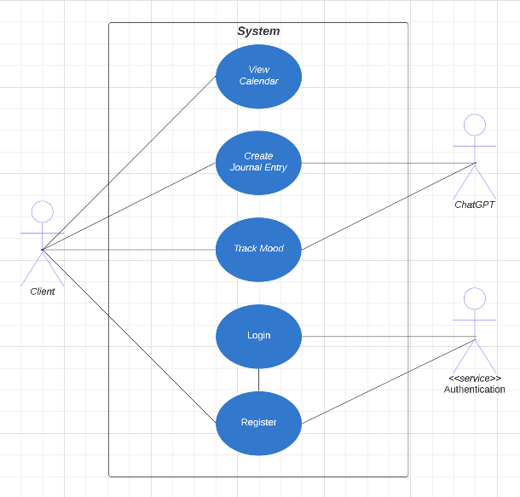

[**Figma Wireframe**](https://www.figma.com/proto/FKrfMb5zXIcPlHgHIE42wz/MindScribe-Wireframe?node-id=5-375&scaling=min-zoom&page-id=0%3A1&starting-point-node-id=5%3A375)